**LP-1 SPOS LA3**

**Neeti Kurulkar**

**Write a program to simulate CPU Scheduling Algorithms: FCFS, SJF (Preemptive), Priority (Non-Preemptive) and Round Robin (Preemptive).**

1. **FCFS:**

**import java.util.*;**

**class Process {**

**String id;**

**int arrival_time;**

**int burst_time;**

**int completion_time;**

**int turn_around_time;**

**int waiting_time;**

**Process() {}**

**Process(String pid, int ar, int br) {**

**id = pid;**

**arrival_time = ar;**

**burst_time = br;**

**}**

**}**

**public class Main {**

**public static void main(String[] args) {**

**Scanner sc = new Scanner(System.in);**

**System.out.print("Enter Number of Processes: ");**

**int n = sc.nextInt();**

**Process[] process_queue = new Process[n];**

**Process temp = new Process();**

**String pid;**

**int ar, br;**

**float avgwt = 0, avgtat = 0;**

**for (int i = 0; i < n; i++) {**

**System.out.print("Enter Arrival Time for Process " + (i + 1) + ": ");**

**ar = sc.nextInt();**

**System.out.print("Enter Burst Time for Process " + (i + 1) + ": ");**

**br = sc.nextInt();**

**process_queue[i] = new Process(("p" + (i+1)), ar, br);**

**}**

**// Sorting based on arrival time**

**for (int i = 0; i < n; i++) {**

**for (int j = 0; j < (n - i - 1); j++) {**

**if (process_queue[j].arrival_time > process_queue[j + 1].arrival_time) {**

**temp = process_queue[j];**

**process_queue[j] = process_queue[j + 1];**

**process_queue[j + 1] = temp;**

**}**

**}**

**}**

**// Calculating completion, turnaround, and waiting times**

**for (int i = 0; i < n; i++) {**

**if (i == 0) {**

**process_queue[i].completion_time = process_queue[i].arrival_time + process_queue[i].burst_time;**

**} else {**

**if (process_queue[i].arrival_time > process_queue[i - 1].completion_time) {**

**process_queue[i].completion_time = process_queue[i].arrival_time + process_queue[i].burst_time;**

**} else {**

**process_queue[i].completion_time = process_queue[i - 1].completion_time + process_queue[i].burst_time;**

**}**

**}**

**process_queue[i].turn_around_time = process_queue[i].completion_time - process_queue[i].arrival_time;**

**process_queue[i].waiting_time = process_queue[i].turn_around_time - process_queue[i].burst_time;**

**avgwt += process_queue[i].waiting_time;**

**avgtat += process_queue[i].turn_around_time;**

**}**

**// Display the process details**

**System.out.println("--------------------------------------------------------------------");**

**System.out.println("Process\t\tArrival Time\tBurst Time\tCompletion Time\tTurnaround Time\tWaiting Time");**

**System.out.println("--------------------------------------------------------------------");**

**for (int i = 0; i < n; i++) {**

**System.out.println(process_queue[i].id + "\t\t" + process_queue[i].arrival_time + "\t\t" + process_queue[i].burst_time + "\t\t" + process_queue[i].completion_time + "\t\t" + process_queue[i].turn_around_time + "\t\t" + process_queue[i].waiting_time);**

**}**

**// Display average waiting and turnaround times**

**System.out.println("Average Waiting Time = " + (avgwt / n));**

**System.out.println("Average Turn Around Time = " + (avgtat / n));**

**sc.close();**

**}**

**}**

**Output:**

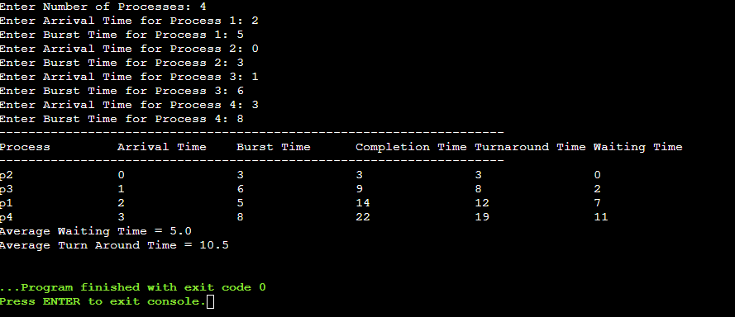

1. **SJF (Preemptive):**

**import java.util.Scanner;**

**class Process {**

**String id;**

**int arrival_time;**

**int burst_time;**

**int completion_time;**

**int turn_around_time;**

**int waiting_time;**

**int remaining_time;**

**boolean isCompleted;**

**Process(String pid, int ar, int br) {**

**id = pid;**

**arrival_time = ar;**

**burst_time = br;**

**remaining_time = br;**

**isCompleted = false;**

**}**

**}**

**public class Main {**

**public static void main(String[] args) {**

**Scanner sc = new Scanner(System.in);**

**System.out.print("Enter number of processes: ");**

**int n = sc.nextInt();**

**Process[] process_queue = new Process[n];**

**int total_completed = 0, current_time = 0;**

**float avgwt = 0, avgtat = 0;**

**for (int i = 0; i < n; i++) {**

**System.out.print("Enter Arrival Time for Process " + (i + 1) + ": ");**

**int ar = sc.nextInt();**

**System.out.print("Enter Burst Time for Process " + (i + 1) + ": ");**

**int br = sc.nextInt();**

**process_queue[i] = new Process(("p" + (i+1)), ar, br);**

**}**

**while (total_completed < n) {**

**int min_burst_index = n;**

**int min_burst_time = Integer.MAX_VALUE;**

**// Find the process with the minimum remaining burst time that has arrived**

**for (int i = 0; i < n; i++) {**

**if (process_queue[i].arrival_time <= current_time &&**

**!process_queue[i].isCompleted &&**

**process_queue[i].remaining_time < min_burst_time) {**

**min_burst_time = process_queue[i].remaining_time;**

**min_burst_index = i;**

**}**

**}**

**if (min_burst_index == n) {**

**current_time++;**

**} else {**

**process_queue[min_burst_index].remaining_time--;**

**current_time++;**

**if (process_queue[min_burst_index].remaining_time == 0) {**

**process_queue[min_burst_index].completion_time = current_time;**

**process_queue[min_burst_index].turn_around_time =**

**process_queue[min_burst_index].completion_time -**

**process_queue[min_burst_index].arrival_time;**

**process_queue[min_burst_index].waiting_time =**

**process_queue[min_burst_index].turn_around_time -**

**process_queue[min_burst_index].burst_time;**

**process_queue[min_burst_index].isCompleted = true;**

**total_completed++;**

**avgwt += process_queue[min_burst_index].waiting_time;**

**avgtat += process_queue[min_burst_index].turn_around_time;**

**}**

**}**

**}**

**System.out.println("--------------------------------------------------------------------------");**

**System.out.println("Process\t\tArrival Time\tBurst Time\tCompletion Time\tTurnaround Time\tWaiting Time");**

**System.out.println("--------------------------------------------------------------------------");**

**for (int i = 0; i < n; i++) {**

**System.out.println(process_queue[i].id + "\t\t" +**

**process_queue[i].arrival_time + "\t\t" +**

**process_queue[i].burst_time + "\t\t" +**

**process_queue[i].completion_time + "\t\t" +**

**process_queue[i].turn_around_time + "\t\t" +**

**process_queue[i].waiting_time);**

**}**

**System.out.println("\nAverage Turn Around Time: " + (avgtat / n));**

**System.out.println("Average Waiting Time: " + (avgwt / n));**

**sc.close();**

**}**

**}**

**Output:**

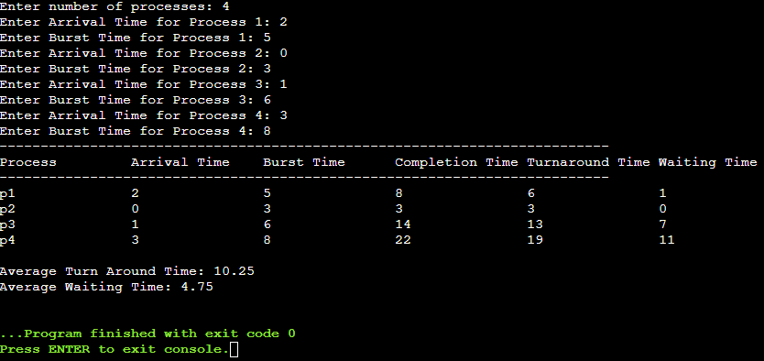

1. **Round Robin:**

**import java.util.Scanner;**

**class Process {**

**String id;**

**int arrival_time;**

**int burst_time;**

**int remaining_bt;**

**int completion_time;**

**int turnaround_time;**

**int waiting_time;**

**boolean is_completed;**

**Process(String pid, int at, int bt) {**

**id = pid;**

**arrival_time = at;**

**burst_time = bt;**

**remaining_bt = bt; // Remaining burst time is initially equal to burst time**

**is_completed = false;**

**}**

**}**

**public class Main {**

**public static void main(String[] args) {**

**Scanner sc = new Scanner(System.in);**

**System.out.print("Enter the number of processes (maximum 10): ");**

**int n = sc.nextInt();**

**Process[] process_queue = new Process[n];**

**System.out.println("Enter the Arrival Time and Burst Time for each process:");**

**for (int i = 0; i < n; i++) {**

**System.out.print("P" + (i + 1) + " (Arrival Time): ");**

**int at = sc.nextInt();**

**System.out.print("P" + (i + 1) + " (Burst Time): ");**

**int bt = sc.nextInt();**

**process_queue[i] = new Process("P" + (i + 1), at, bt);**

**}**

**System.out.print("Enter the quantum time: ");**

**int quantum_time = sc.nextInt();**

**// Sort processes by arrival time using Bubble Sort**

**for (int i = 0; i < n - 1; i++) {**

**for (int j = 0; j < n - i - 1; j++) {**

**if (process_queue[j].arrival_time > process_queue[j + 1].arrival_time) {**

**Process temp = process_queue[j];**

**process_queue[j] = process_queue[j + 1];**

**process_queue[j + 1] = temp;**

**}**

**}**

**}**

**// Initialize variables**

**int current_time = 0; // Tracks the current time**

**int completed = 0; // Number of completed processes**

**int total_tat = 0, total_wt = 0; // Total Turnaround Time and Waiting Time**

**// Process execution using Round Robin**

**while (completed < n) {**

**boolean process_executed = false;**

**for (int i = 0; i < n; i++) {**

**Process p = process_queue[i];**

**// Process can execute only if it's arrived and not yet completed**

**if (p.arrival_time <= current_time && !p.is_completed) {**

**process_executed = true;**

**// If remaining burst time is more than quantum time, execute for quantum time**

**if (p.remaining_bt > quantum_time) {**

**current_time += quantum_time;**

**p.remaining_bt -= quantum_time;**

**} else {**

**// Process completes in this round**

**current_time += p.remaining_bt;**

**p.remaining_bt = 0;**

**p.completion_time = current_time;**

**// Calculate turnaround time and waiting time**

**p.turnaround_time = p.completion_time - p.arrival_time;**

**p.waiting_time = p.turnaround_time - p.burst_time;**

**total_tat += p.turnaround_time;**

**total_wt += p.waiting_time;**

**p.is_completed = true; // Mark process as completed**

**completed++;**

**}**

**}**

**}**

**// If no process was executed, advance time to the next arriving process**

**if (!process_executed) {**

**current_time++;**

**}**

**}**

**// Display process information**

**System.out.println("------------------------------------------------------------------------------------");**

**System.out.println("Process\t\tArrival Time\tBurst Time\tCompletion Time\tTurnaround Time\tWaiting Time");**

**System.out.println("------------------------------------------------------------------------------------");**

**for (int i = 0; i < n; i++) {**

**Process p = process_queue[i];**

**System.out.println(p.id + "\t\t" + p.arrival_time + "\t\t" + p.burst_time + "\t\t" +**

**p.completion_time + "\t\t" + p.turnaround_time + "\t\t" + p.waiting_time);**

**}**

**// Calculate and display average turnaround time and waiting time**

**System.out.println("\nAverage Turnaround Time = " + (float) total_tat / n);**

**System.out.println("Average Waiting Time = " + (float) total_wt / n);**

**sc.close();**

**}**

**}**

**Output:**

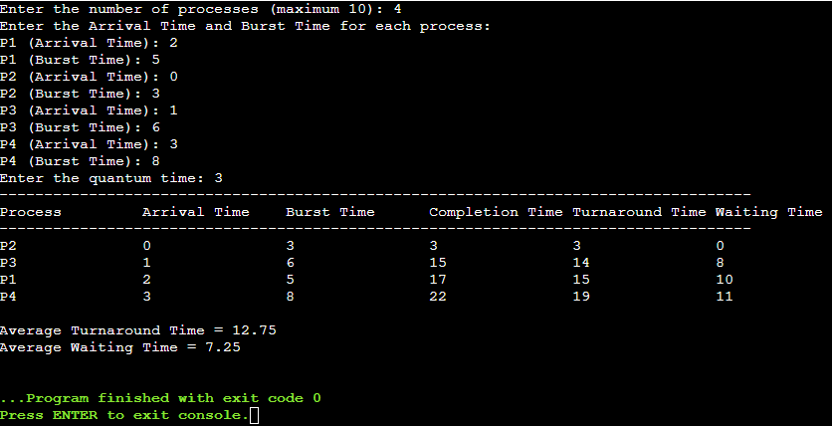

1. **Priority (non-preemptive):**

**import java.util.*;**

**class Process {**

**String id;**

**int arrival_time;**

**int burst_time;**

**int priority;**

**int completion_time;**

**int turn_around_time;**

**int waiting_time;**

**boolean isCompleted = false;**

**Process(String pid, int ar, int br, int pr) {**

**id = pid;**

**arrival_time = ar;**

**burst_time = br;**

**priority = pr;**

**}**

**}**

**public class Main {**

**public static void main(String[] args) {**

**Scanner sc = new Scanner(System.in);**

**System.out.print("Enter Number of Processes: ");**

**int n = sc.nextInt();**

**Process[] process_queue = new Process[n];**

**for (int i = 0; i < n; i++) {**

**System.out.print("Enter Arrival Time for Process " + (i + 1) + " : ");**

**int ar = sc.nextInt();**

**System.out.print("Enter Burst Time for Process " + (i + 1) + " : ");**

**int br = sc.nextInt();**

**System.out.print("Enter Priority for Process " + (i + 1) + " : ");**

**int pr = sc.nextInt();**

**process_queue[i] = new Process(("p" + (i+1)), ar, br, pr);**

**}**

**// Sort processes based on arrival time**

**Arrays.sort(process_queue, Comparator.comparingInt(p -> p.arrival_time));**

**int currentTime = 0;**

**int completedProcesses = 0;**

**float total_tat = 0, total_wt = 0;**

**// Continue until all processes are completed**

**while (completedProcesses < n) {**

**// Find process with highest priority from arrived processes**

**Process currentProcess = null;**

**int highestPriority = Integer.MAX_VALUE;**

**for (Process p : process_queue) {**

**if (!p.isCompleted && p.arrival_time <= currentTime && p.priority < highestPriority) {**

**highestPriority = p.priority;**

**currentProcess = p;**

**}**

**}**

**if (currentProcess != null) {**

**// Process found, execute it**

**currentProcess.completion_time = currentTime + currentProcess.burst_time;**

**currentProcess.turn_around_time = currentProcess.completion_time - currentProcess.arrival_time;**

**currentProcess.waiting_time = currentProcess.turn_around_time - currentProcess.burst_time;**

**total_tat += currentProcess.turn_around_time;**

**total_wt += currentProcess.waiting_time;**

**currentProcess.isCompleted = true;**

**completedProcesses++;**

**currentTime = currentProcess.completion_time;**

**} else {**

**// If no process is ready, increment time**

**currentTime++;**

**}**

**}**

**// Print process details**

**System.out.println("------------------------------------------------------------------------------------------------------");**

**System.out.println("Process\t\tArrival Time\tBurst Time\tCompletion Time\tTurnaround Time\tWaiting Time");**

**System.out.println("------------------------------------------------------------------------------------------------------");**

**for (int i = 0; i < n; i++) {**

**System.out.println(process_queue[i].id + "\t\t" + process_queue[i].arrival_time + "\t\t\t" +**

**process_queue[i].burst_time + "\t\t\t" + process_queue[i].completion_time + "\t\t\t" +**

**process_queue[i].turn_around_time + "\t\t\t" + process_queue[i].waiting_time);**

**}**

**System.out.println("\nAverage Waiting Time = " + (total_wt / n));**

**System.out.println("Average Turn Around Time = " + (total_tat / n));**

**sc.close();**

**}**

**}**

**Output:**

